# 

INTERNET OF THINGS EMBEDDED FIRMWARE

FINAL COURSE PROJECT REPORT (INDIVIDUAL)

# REMOTELY CONTROLLED WHEELCHAIR

-Deepesh Sonigra

# REMOTE CONTROL OF WHEELCHAIR USING GESTURE CONTROL

**PROBLEM BEING ADDRESSED**

The wheelchairs are usually controlled by a joystick attached to it. It is not possible to control the wheelchair remotely. It is not possible to provide maneuvering assistance if need be. We plan to implement remote maneuvering assistance.

**SOLUTION**

Blue Gecko is used as a low power node which is interfaced with a gesture sensor. When a gesture is detected Low Power Node communicates with the Friend Node. Depending upon the gesture the Friend Node moves the wheelchair.

We plan to overcome range limitation by using Mesh Relays. If the wheelchair is out of range of the Remote, the Remote(LPN) communicates with the nearest Friend Node which relays the message to the Wheelchair(Friend) the Remote wishes to control.

Central Device can be used to change the gesture parameters of LPN node and also the speed of the Wheelchair.

**FUNCTIONAL BLOCK DIAGRAM**

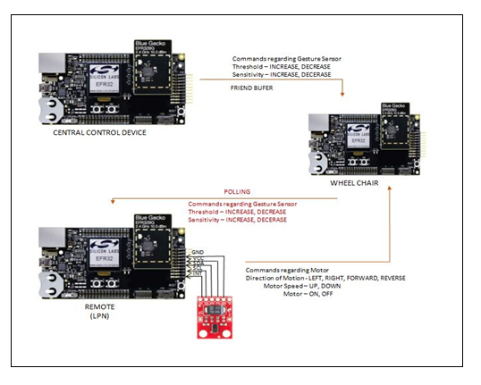

**SENSOR USED**

Gesture sensor -[Part Number:SEN-12787](https://www.kr4.us/SparkFun-RGB-and-Gesture-Sensor-APDS-9960.html?gclid=CjwKCAjwvNXeBRAjEiwAjqYhFrAPQsXOrvbyVqTzvKyOrKxKV3qFayE9wbkDJTYRMOYz6OMA9krA_BoC-LAQAvD_BwE)

Gesture sensor APDS 9960  is a Spark Fun RGB and Gesture Sensor, a that offers ambient light and color measuring, proximity detection, and touch less gesture sensing.

Interface Type - I2C

**MODULES IMPLEMENTED**

**1) Mesh Provisioning**

* OOB Authentication is used where a OTP is displayed on LCD and user is asked to enter it.

**2) Gesture based Remote Control**

* This a Low Power Node with Client Model.
* Low Power Node responsible to send changes in a state to Friend Node.
* Generic Level State Server Model

**3)Services Implemented**

* **Service 1** : Level States- Left, Right, Forward, Backward
* **Service 2** : Level States - Motor Speed, Motor On/Off.

**PERSISTENT DATA**

* Gesture sensor parameters like threshold and sensitivity are stored in Persistent Data.
* User can update these parameters through Central Device.
* Central Device communicates to LPN through Friend node with updated parameters and LPN saves it to its persistent data so that if device is powered down, user iis not required to update these values again.
* Persistent Data is stored every time LPN polls message from friend if central device has requested the change.

**FLOWCHART**

The flowchart is divided into 3 parts

* Provisioning of Device
* Friend Low Power Connection
* LPN Gesture Connection

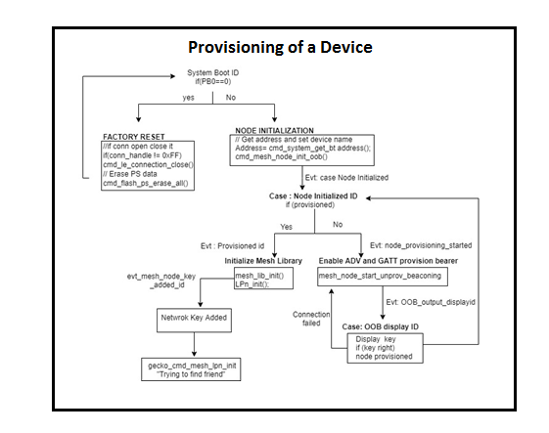

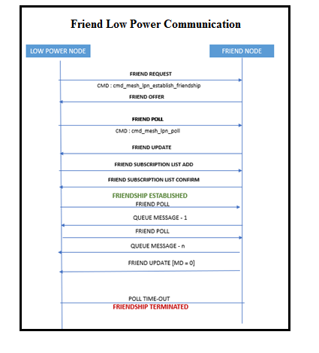

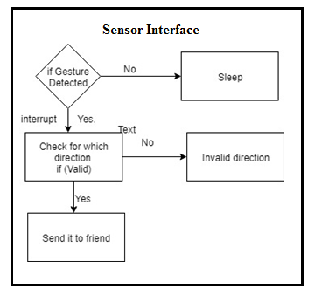

**ENERGY MANAGEMENT**

* The Gesture based Remote Control Device is a Low Power Node which means it's receiver radio is off most of the time.
* The Gesture sensor is interrupt based which means interrupts occur only when the gesture is detected.
* LPN wakes up as soon as the interrupt occurs and sends the level (data encoded at different levels) to the appropriate server(Friend Node).
* Gesture Sensor communicates using I2C protocol . AS LPN is configured as slave device sleeps in EM2.
* Friend Polling is done every 4 seconds as the data which LPN receives through friend is gesture sensitivity and threshold which is not a critical data.

**SECURITY IMPLEMENTED**

* Out of Bound Authentication is implemented during provisioning using Input OOB Method. A 4-digit random Pass-Key is displayed on each node, the same needs to be input in the Bluetooth Mesh App for successful provision.
* The Out of Band channel should be resistant to MITM attacks.

**LESSONS LEARNT**

**A) Bluetooth Mesh**

* Method to implement the OOB authentication during provisioning. OOB authentication is a security feature implemented during provisioning where a passkey is printed on the device to be provisioned and passkey is required to be entered in the phone.
* Generic Level Model is used to communicate states between the devices. LPN had 8 different states ,each state was encoded as a different level value which was sent to the server . Level is a 16 bit value and can be used to communicate 65536 different states.
* How to configure the isc file to add Client/Server Models. LPN was required to be configured as Client Generic Level. DCD file is modified when we make changes in the isc file.

**B) Interrupt Service Routine**

* Instead of using an ISR I have used a call back function for GPIO interrupts. A bit of setup code stores the address of the ISR function in the interrupt vector table to say "call me back at this address when the interrupt occurs".

**C) Sensor Interface**

* Interfacing the Gesture sensor and configuring its registers to track the movement of gesture. Gesture detection utilizes four directional photodiodes, integrated with visible blocking filter, to accurately sense simple UP-DOWN-RIGHT-LEFT gestures or more complex gestures.

**PROJECT PLAN**

|  |  |  |
| --- | --- | --- |
| Understanding Mesh SDK | 10/29 | Completed |
| a. Developing persistent memory routine | 11/1 | Completed |
| b. Interface software to Gesture sensor | 11/3 | Completed |
| c. Integrating Gesture sensor to application code | 11/5 | Completed |
| d. Checking sensor parameters | 11/7 | Completed |
| e. Integrating LCD to application code | 11/9 | Completed |
| f. Load Power Management of sensor | 11/11 | Completed |
| g. Developing Models | 11/15 | Completed |
| h. Developing Bluetooth Mesh Friend Relationship | 11/19 | Completed |
| i. Integrating team member projects | 11/21 | Completed |
| i. Validation of the project ... | 11/25 | Completed |

**VERIFICATION PLAN**

|  |  |  |  |  |  |  |
| --- | --- | --- | --- | --- | --- | --- |
| Sr. no | To be verified | Definition of passing | Date performed | Tested by | Measured result | Passed |
| 1 | Developing persistent memory routine | Gesture state and Speed of Motor and IR sensor should be retained even after Power-On Reset | 11/3/2018 | Deepesh &  Madhumitha | States of Motor and Gesture Sensor retained. | Yes |
| 2 | Interfacing LCD Display | Display Motor States, Direction, Speed, if Device is Provisioned and module address and states | 11/5/2018 | Deepesh &  Madhumitha | Addresses and States were dynamically printed | Yes |
| 3 | Interface software to Gesture Sensor | I2C interface, Interrupt routine | 11/16/2018 | Deepesh | Gesture Sensor is outputting the accurate values | Yes |
| 4 | Updating Gesture Commands using Central Control Device | Central Control Device issues commands to change Gesture Commands directed to LPN, Friend Node should Buffer it and send to LPN when it polls | 12/8/2018 | Deepesh | Central Device is used to change the sensitivity and threshold of gesture sensor | Yes |
| 5 | Generic Level Server Model on Remote Control | State used to determine Left,Right,Forward&Backward | 20/11/18 | Deepesh | Levels are used to differentiate between directions | Yes |
| 6 | Validation of Mesh hoping | LPN connects to another friend which acts as relay between the Remote (LPN ) and Motor(Friend) if Remote and Motor are out of range. | 12/7/2018 | Deepesh | LPN connects to closest friend and hops the message to Wheelchair | Yes |
| 7 | OOB Authentication | One time password is generated and Displayed on LCD. User need to enter it | 11/10/18 | Deepesh | One time password is generated and displayed on the module LCD, when we enter that number in our app, module provisioning is completed. | Yes |
| 8 | Integrating All modules | All modules communicate to each other | 12/10/2018 | Madhumitha  & Deepesh | All modules communicateas expected | Yes |

**DIFFICULTIES FACED**

* I faced difficulties in validating the gesture sensor data as it was too sensitive to hand movements
* I faced difficulties in deciding OOB parameters
* The provisioner was quite unpredictable with errors during the provisioning process that led us to believe there was something wrong with our code initially, leading to a couple of futile debugging sessions.
* Low Power used to terminate friendship after some time and try to establish friendship again

**SUMMARY**

* Once the gesture is detected the LPN wakes up and sends the gesture state to the friend node
* Motor Control On/Off and Motor speed can also be controlled by the remote(LPN)
* The LPN connects to the closest friend and hops the message to the Wheelchair
* The Central device is used to change the gesture threshold and sensitivity by sending the change to LPN through friend Polling.